Scott Aniol
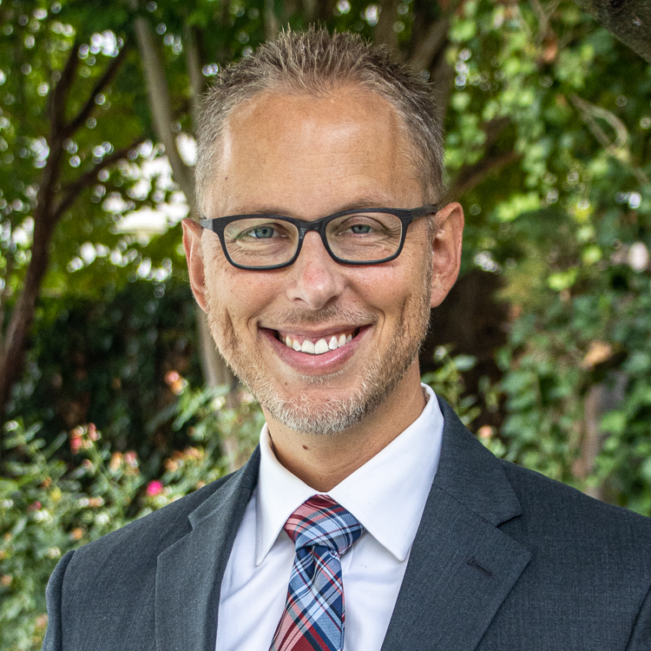
BLOG

Executive Vice President and Editor-in-chief
Scott Aniol, PhD, is a teacher of culture, worship, aesthetics, and church ministry philosophy, he lectures around the country in churches, conferences, and seminaries, and he has authored several books including By the Waters of Babylon and Let the Little Children Come, and dozens of articles published in theological journals. In addition to his role with G3, Scott is Professor of Patoral Theology at Grace Bible Theological Seminary in Conway, Arkansas. Scott holds a masters degree in theological studies (SWBTS), a masters degree in aesthetics (NIU), and a PhD in pastoral theology with an emphasis on worship (SWBTS). Scott and his wife, Becky, have four children: Caleb, Kate, Christopher, and Caroline.

